Church Profile
for

Southwell Baptist Church

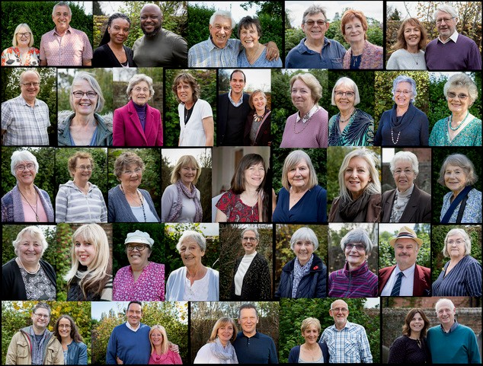

www.southwellbaptistchurch.co.uk
info@southwellbaptistchurch.co.uk

Introduction. Southwell Baptist Church is a small but active church with a reputation for being friendly and welcoming. We embrace the ethos of every person ministry, and most members of the congregation are actively involved in some way. Our church family comes from a wide variety of denominational backgrounds and Christian traditions and consists mainly of mature adults.
Currently led by a well-supported Interim Steering Group (ISG), we are very involved with Churches Together in Southwell, a collaboration of the seven churches in the town, and would like to see this partnership continue. We would, however, still like to keep our own identity as Bible-based, spirit-led Baptists, to become even more involved with the community around us, and to grow God’s church.
We would welcome new ideas, challenges, and opportunities for spirit-led growth. We have an appetite for change and a strong belief that God has plans for this church that we are yet to discover and are searching for a minister with vision and energy who can inspire and encourage us towards this fresh expression of church.

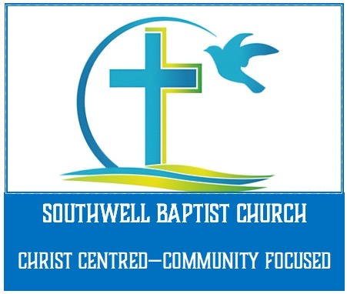
Vision and Beliefs
Our agreed statement is that we are Christ Centred, Community Focused, and that our areas for ongoing development are Faith, Fellowship and Frontline, always with God at the centre.
We pray that, with the help of a new minister, we can discern God’s will for our church and grow in faith, strengthen our fellowship, and seek out new opportunities for spreading His word in our community.
As a member of the Baptist Union we hold to their Declaration of Principles.

Church Now
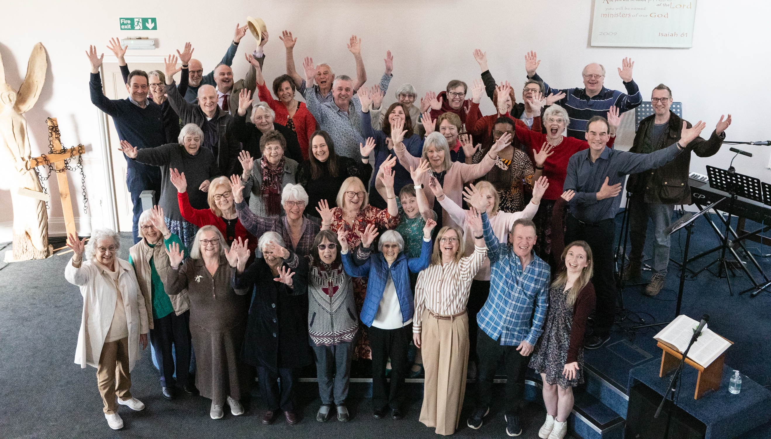
a) The People
Southwell is a vibrant market town, and our congregation is drawn from the town itself, surrounding villages, and from the wider area. We currently have around 50 regular attendees, 35 of which are members, many of whom are retired or practicing professionals. The gender split is 74% female / 26% male. We aim to be inclusive and to ensure everyone receives a warm welcome.
The current leadership team consists of six members, two male and four female, three of whom have been in the position since February 2024 and three joining in February 2026.
We employ two part-time staff: a church administrator and a cleaner.
b) Services
We have regular services at 10.30am on Sunday mornings, with a preceding prayer meeting at 10am for anyone wishing to attend. Since our last minister left in 2023 our services have been hosted by a committed team of service and worship leaders, ably supported by a small band of musicians, a prayer ministry team, and our dedicated technology team.
The message has been brought by a mixture of in-house and visiting speakers, all of whom have given thought provoking insights into the word of God, though we look forward to the continuity that a new minister here would bring. Sermons are recorded and can be found on our Southwell Baptist Church Website and YouTube channel.
Our service structure is a mix of sung worship, prayer and preaching, and we share communion on the 3rd Sunday monthly. Occasionally we hold an evening ‘Prayer and Praise’ service, and extra services on important dates in the church calendar e.g. Easter and Christmas.
Every 4-6 weeks we hold Café Church, a more informal service held around tables in the church hall, with light refreshments served throughout, which we encourage members to invite friends to attend.
c) Activities
Though a smaller church, we are very active and keen to strengthen ties both within the fellowship and in the community. Within the fellowship we have five home groups who meet weekly in various venues (including one via Zoom) for Bible study and prayer. Each group has its own personality and preferred way of delivering materials. We also have several prayer triplets who meet informally, and have organized short Bible teaching courses, led by a member of our congregation. Early every Wednesday morning we hold a prayer meeting via Zoom as well as a Sunday morning prayer meeting before the service.
Despite not currently having a minister we have carried on with all aspects of church life, including the organisation of weddings and funerals.
Socially, we hold regular ‘Ladies Who Lunch’ outings, ‘Men’s Curry Nights’ and host various events such as shared Sunday lunches, barbecues, etc. throughout the year. Fellowship and hospitality are an important part of church life here.
We have previously held Church Weekends away and at home, where a speaker from outside the area was invited to lead a full programme.
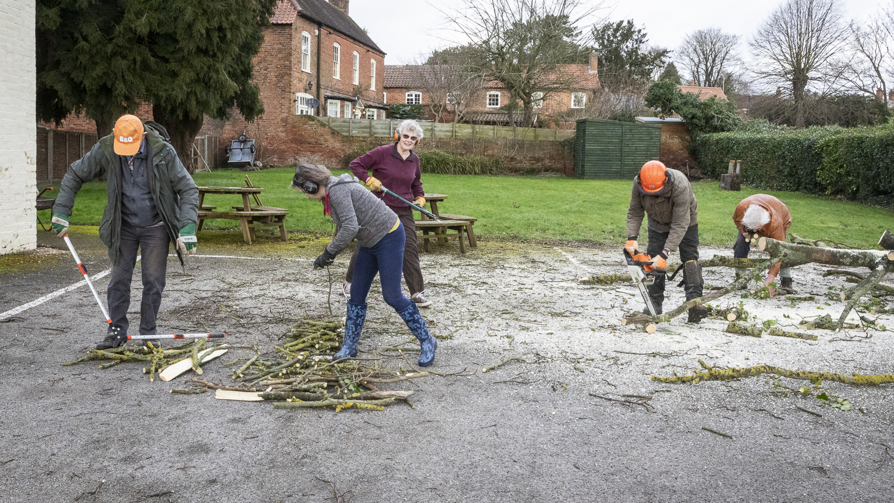
Around every six months we have a work day when volunteers get together at church to catch up on housekeeping, DIY and gardening tasks, and are provided with breakfast as a reward.
Looking outward, we host weekly Renew Wellbeing sessions on Monday afternoons where we welcome a small core group of regulars, some of whom now attend services, plus occasional visitors.
On the first Friday of the month, we have a pop-up café called The Dwelling Place, which has proved to be very popular, and, within that, we also have a Craft & Chatter group which repeats on the third Friday.
The first Tuesday of each month sees a team visit a local care home to take a service to the residents, and members also take a turn on a rota to hold coffee mornings at a second care home.
Around every two to three months we hold a Women’s Breakfast meeting which is well attended and to which people seem happy to invite non-Christian friends.
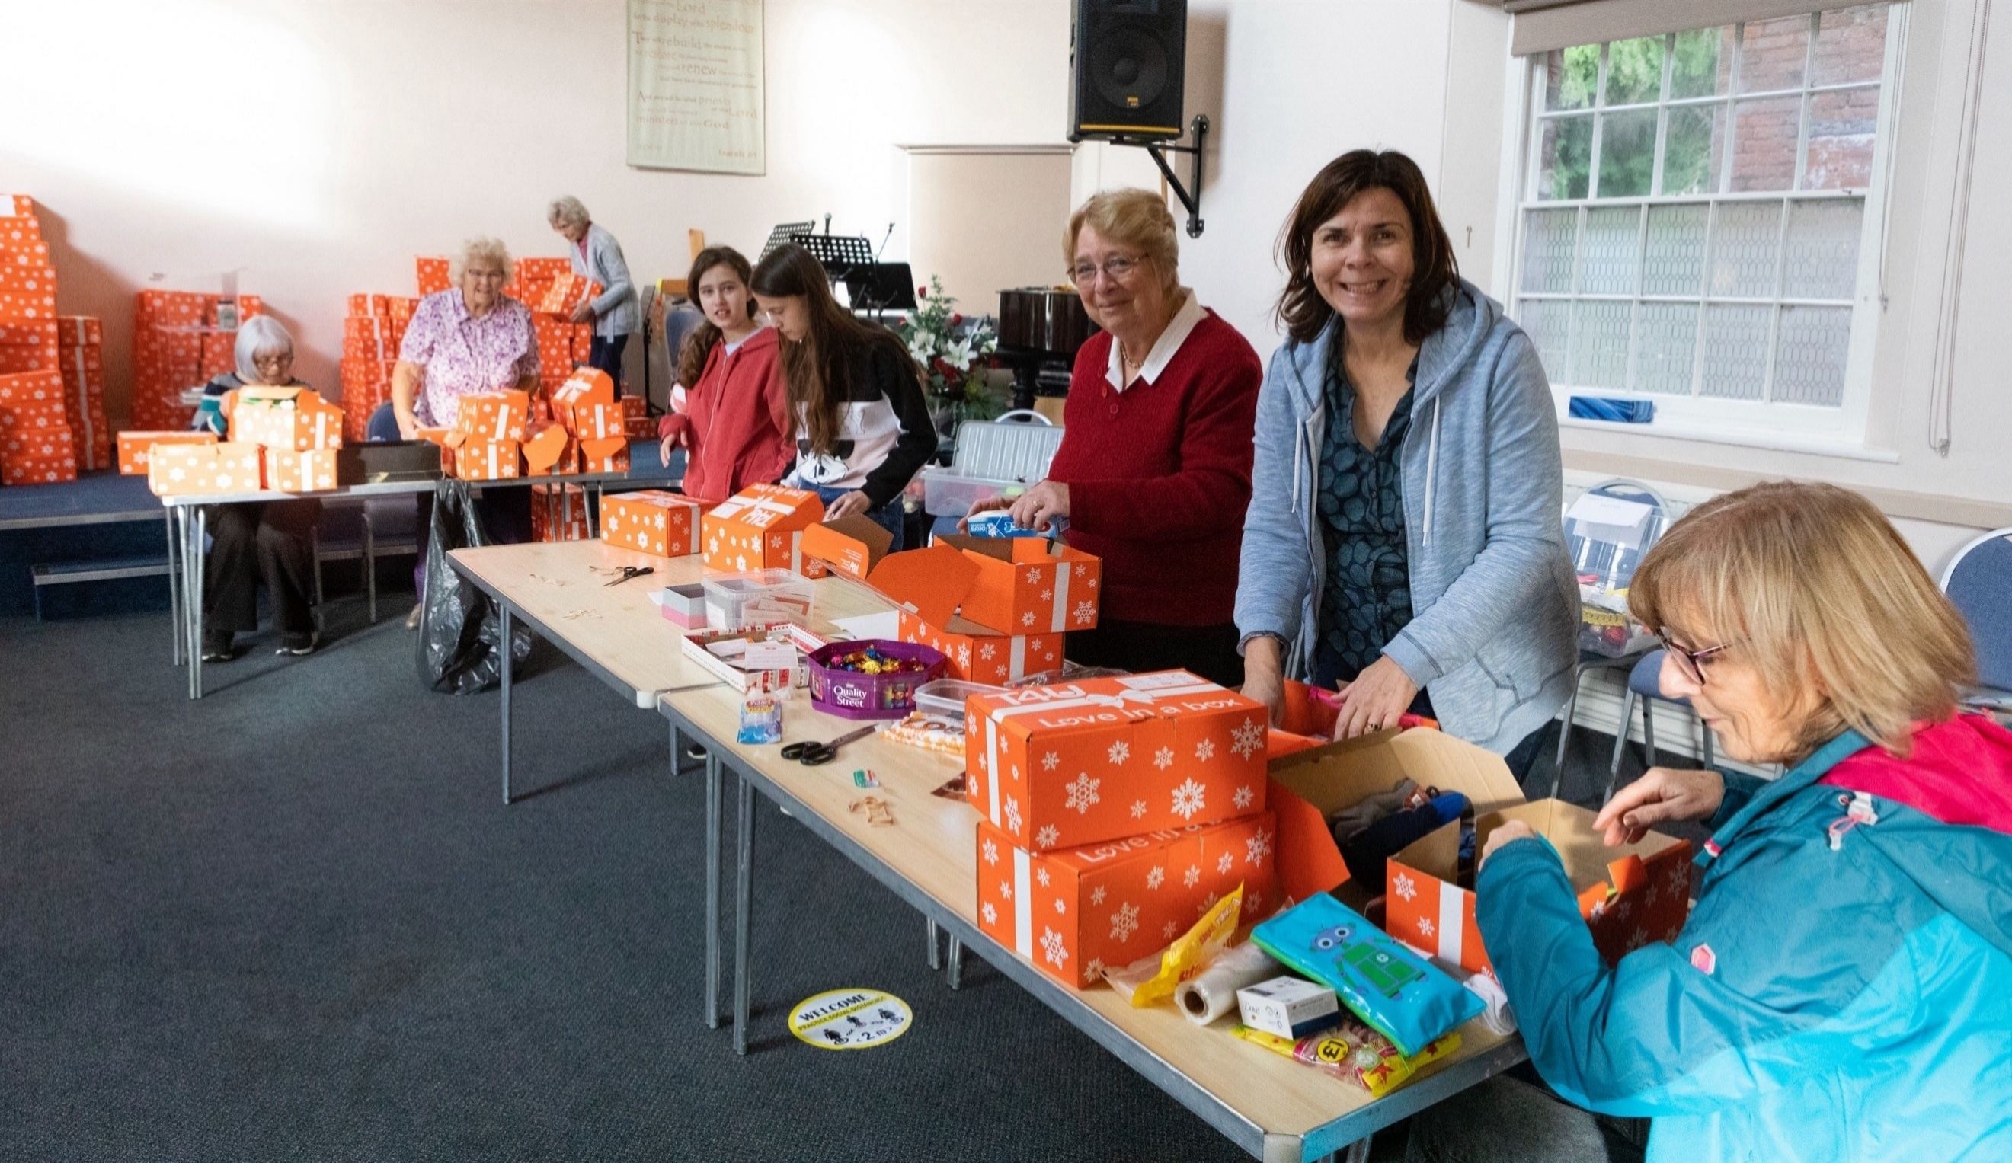
In October we have an annual Christmas shoe box appeal, also acting as a collection and sorting point for the boxes, checking them before they go on to the depot for delivery.
Finally, we have had a foodbank collection point in situ for many years.
All of these activities are organised and staffed by volunteers from the congregation.

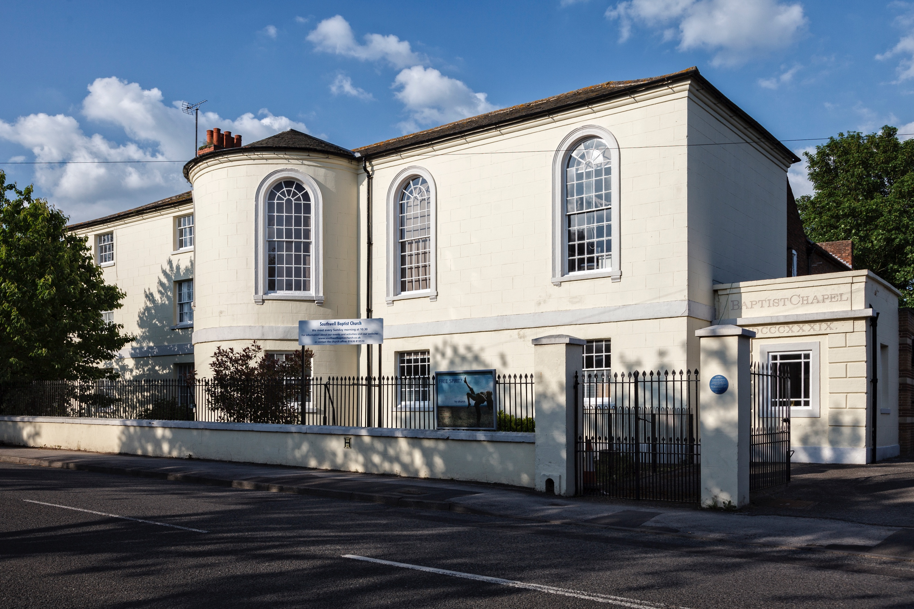
d) The Buildings
The Church is a Grade II listed building which was originally built in 1808 as the first workhouse, then sold when it was found that the premises were too small. Its successor remains in Southwell and is owned by the National Trust. The Church does have a Manse which is attached to the property, which is spacious but is in need of renovation. We would be open to discussion re the form this should take and whether we should look at alternative uses for the manse and provide a housing allowance in lieu.
A good-sized public park lies directly behind the church which can be accessed via a gate from our private car park. We also have a large lawn area adjacent to the parking, and a fenced off garden to the manse.
We have recently undertaken major roof repairs, and the leadership are actively seeking grants to enable more renovations.
The interior consists of an entrance hallway with toilets, with a small inner vestibule and the main sanctuary to the left. To the right is a church hall and kitchen, for which we have a 5* food hygiene rating and which we use regularly for church activities and shared meals.
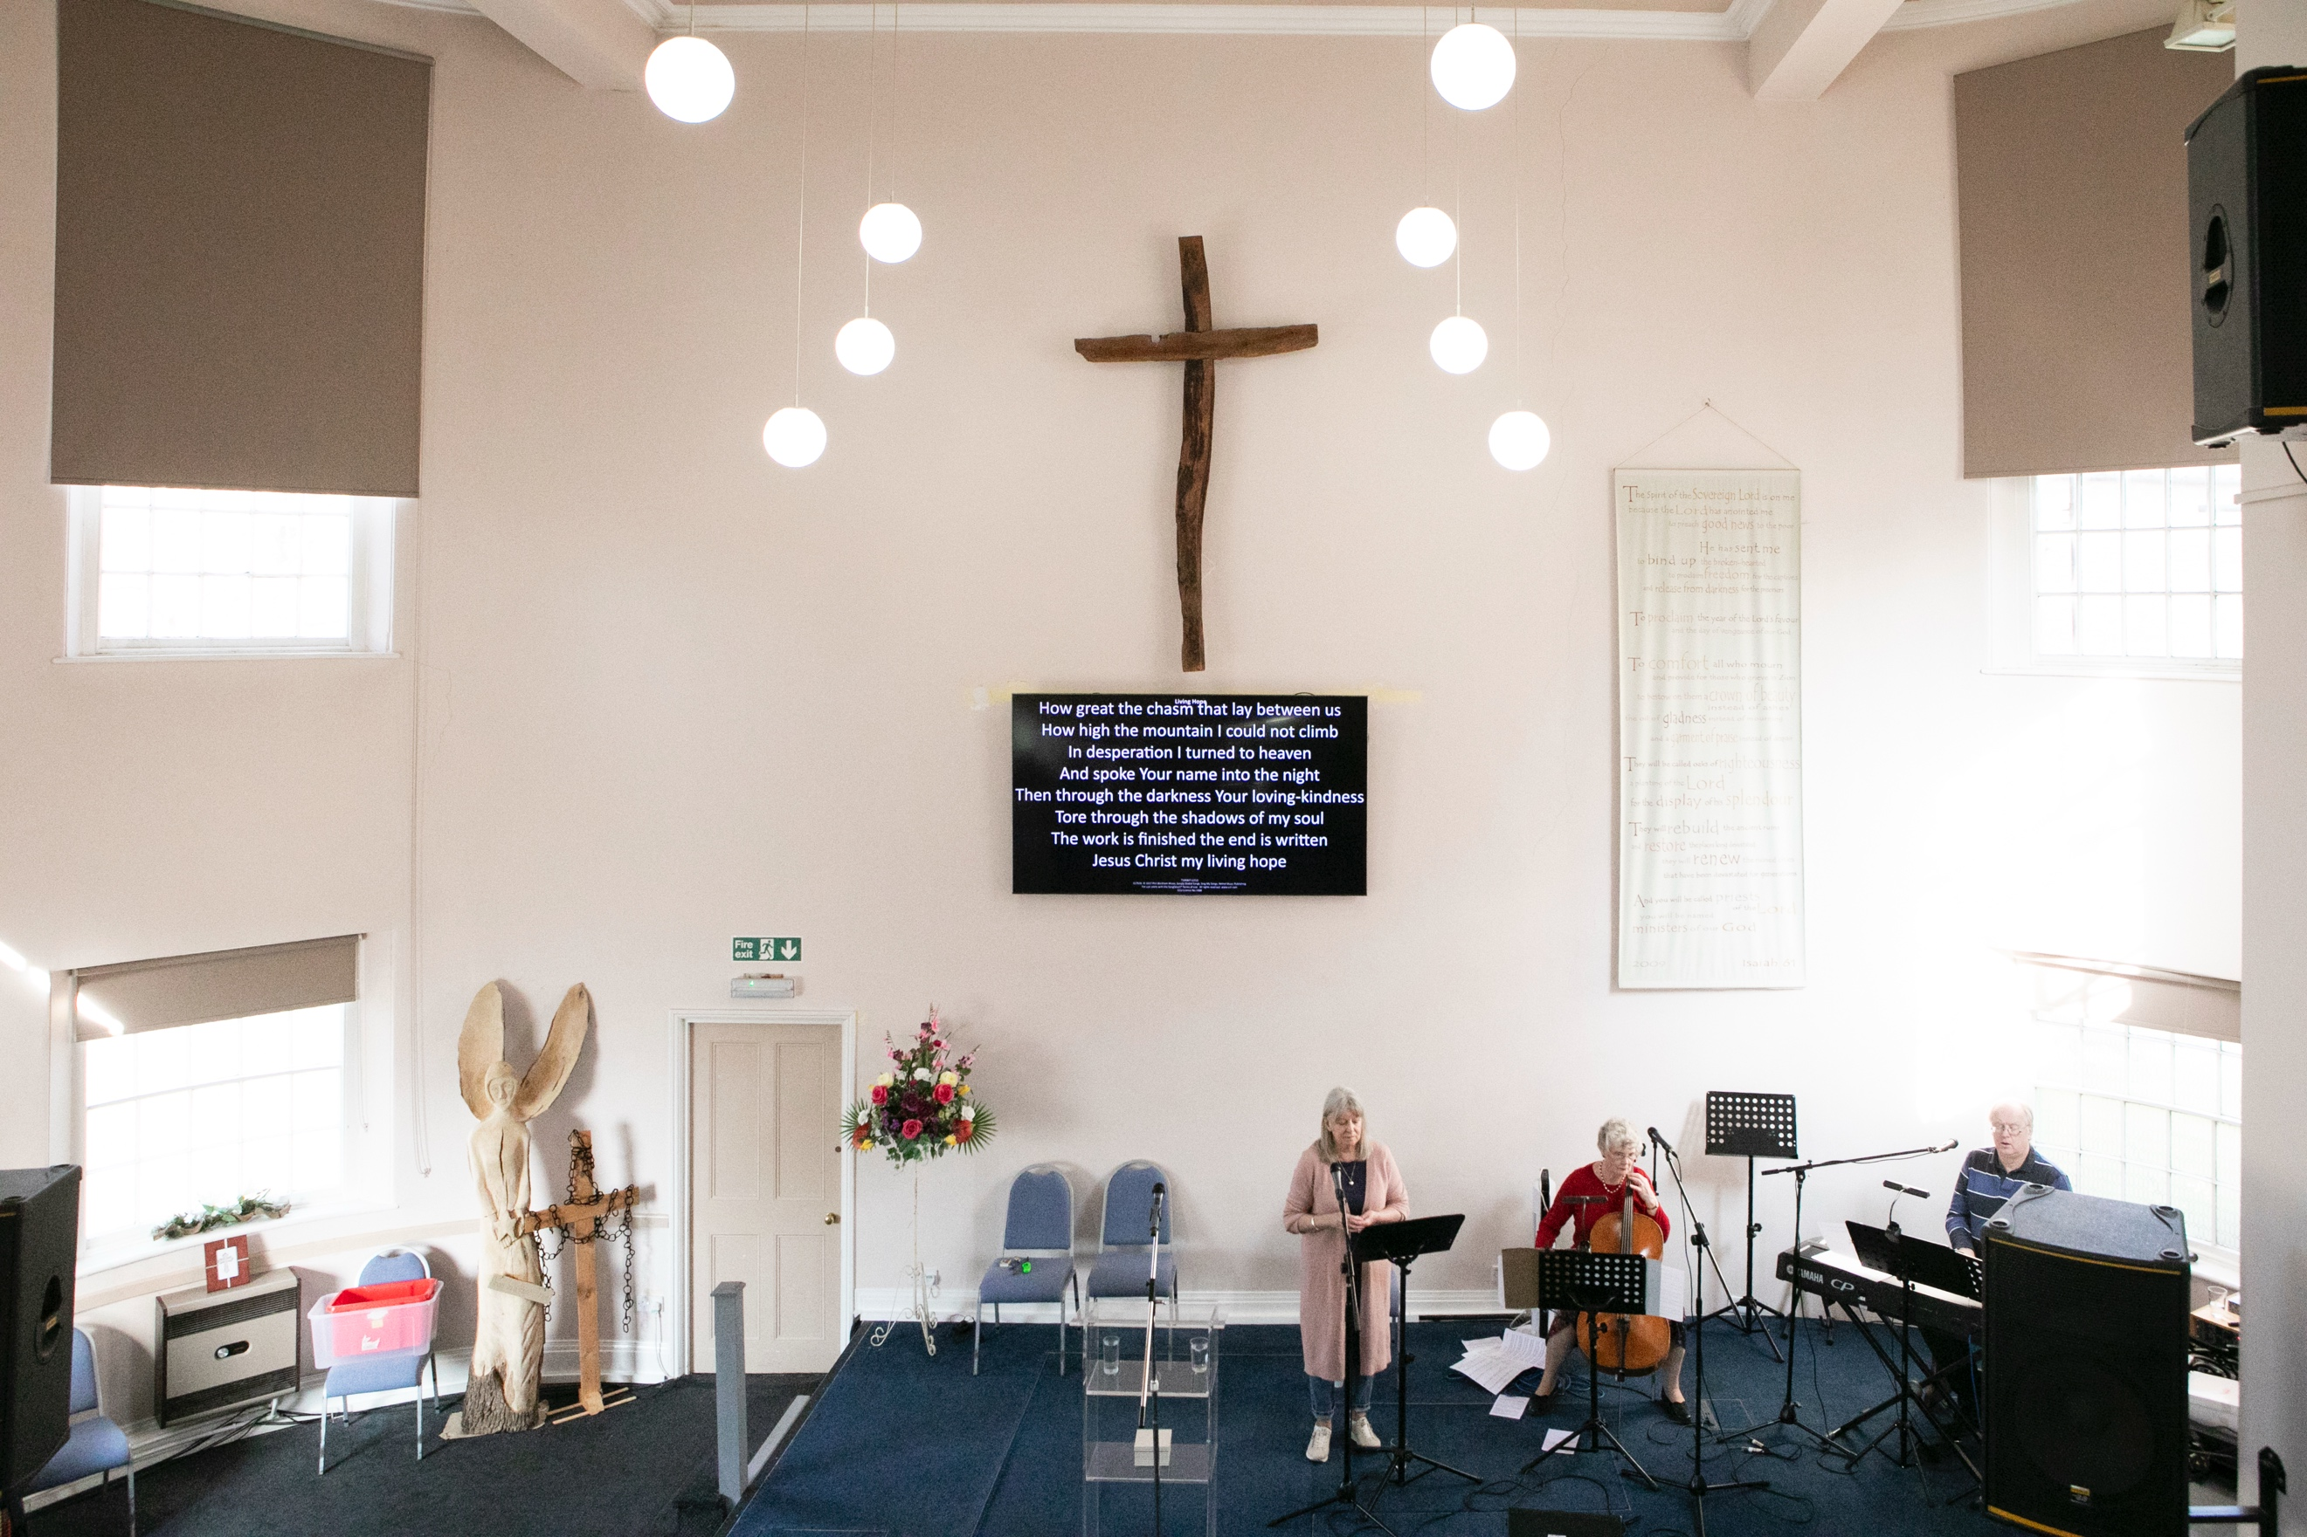
Rising from the hallway we have stairs leading to two further general purpose rooms and the church office to the right, and a small storage room and access to a balcony overlooking the sanctuary to the left.
At the front of the sanctuary we have a raised stage area, which hides the baptistry. We would dearly love to see this used more often!
The building is also used by the local community with the local Slimming World, Flower Club, Pastoral Choir and U3A all holding meetings here.
e) Wider Connections
Baptist: We are members of the East Midlands Baptist Association, the Baptist Union, of Great Britain, and the Evangelical Alliance. We support all of these in prayer and the Home Mission financially.
Ecumenical: We take an active role with Churches Together in Southwell which consists of seven churches; two Anglican, one Catholic, one Methodist, one large Evangelical, a small home church, and ourselves. In the past year the organisation has had something of a revival, with more joint ventures and collaborations taking place, including shared services and a town-wide prayer initiative. We also participated in Lent study groups together with the other churches.
The church ministers meet informally every six weeks for discussion, mutual prayer and support. A leadership member currently attends to represent SBC.
Mission: We have for many years now supported, both financially and in prayer, several named mission workers worldwide – David working in South Africa, Mary & Ramil in the Philippines, Rachel & Julio in Guatemala, and Esther in the Middle East. All of these have connections to SBC and keep in regular contact. Closer to home we support Jericho Rd who work with women in the sex industry in Nottingham, and the Trussell Trust foodbank in Newark. We also act as a collection and checking point for the Teams 4U shoebox appeal each year
The Church We Would Like to See
In a meeting with the congregation and our regional minister, it became clear that we would very much like to:
- see growth in spirituality, faith and discipleship
- be more evangelistic
- grow God’s kingdom
- identify God’s purpose for our church within this community
- be alert to opportunities and be willing to try new things
- increase our Bible knowledge and understanding
- carry on the ethos of ‘every person ministry’
- see gifts and talents being recognised and their use encouraged
- retain the love we have now for God and each other

The Minister We Believe We Need
Since 2023, when our minister responded to a new calling, we have continued to grow as a church under the guidance of an ISG, who replaced the previous Eldership and Deacons leadership structure. We have found this collaborative style of leadership to be both positive and effective, and are looking for a minister who will value and contribute to this approach.
We have been encouraged by seeing God’s church grow in this time with new people joining us. We do recognise that the absence of a settled minister has resulted in reduced continuity in preaching, teaching and pastoral oversight. We believe that a consistent ministry in these areas is important if we are to deepen our faith, grow as disciples of Jesus Christ, and become increasingly confident in living out and sharing the gospel.
We are seeking a minister with a heart for God and a passion for people; someone who is rooted in Scripture, prayerful in their leadership, and able to communicate God’s Word in a way that is relevant, engaging, and challenging so that people of all ages can grow in faith and service.
As we look to the future, we are excited about what God may have in store for us. We are seeking a minister who will work alongside us in discerning God’s vision for our church and community, helping us to identify opportunities for mission and outreach. We would value someone who brings energy, wisdom, creativity and compassion, who will inspire and equip us to embrace new opportunities while building on the strengths of our existing church family. Together we long to grow as a welcoming, Christ-centred church that faithfully serves our community and shares the good news of Jesus with confidence and love.

What we Recognise as Being Needed from Us.
During the meeting with our regional minister, we were asked about our commitment in order to support a new minister. These were the replies:
- Financial and personal commitment to give support
- Prayer support
- A willingness to participate and be present
- To be open-minded, hold onto things lightly and accept change
- To make ourselves available and give our time
- A willingness to be challenged and evaluate what we do, both individually and as a church.

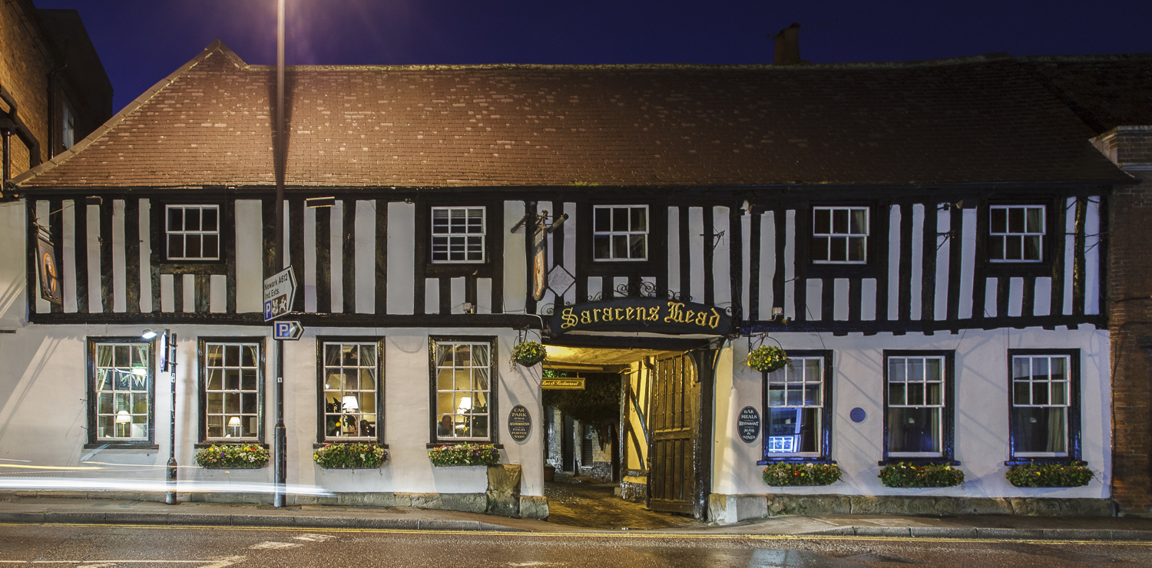
The Area
Southwell is a prosperous, small, but expanding market town (population circa 10,000) which is rich in historical and architectural interest. It played its part in the Civil War when King Charles 1 spent his last night of freedom at the Saracen’s Head before surrendering to the Roundheads. The Bramley apple originates in Southwell and the Bramley Apple Festival is held each year, as are the Musical and Folk festivals.
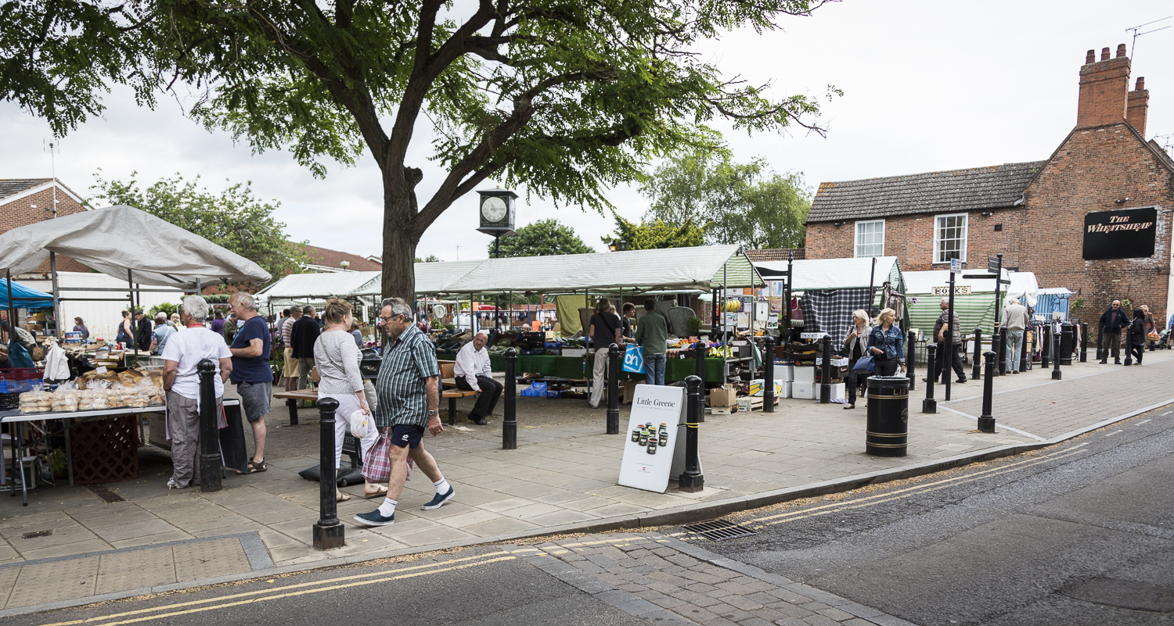
There is a good range of independent retailers and garden centres, a Saturday market, several pubs and a variety of cafés and restaurants.
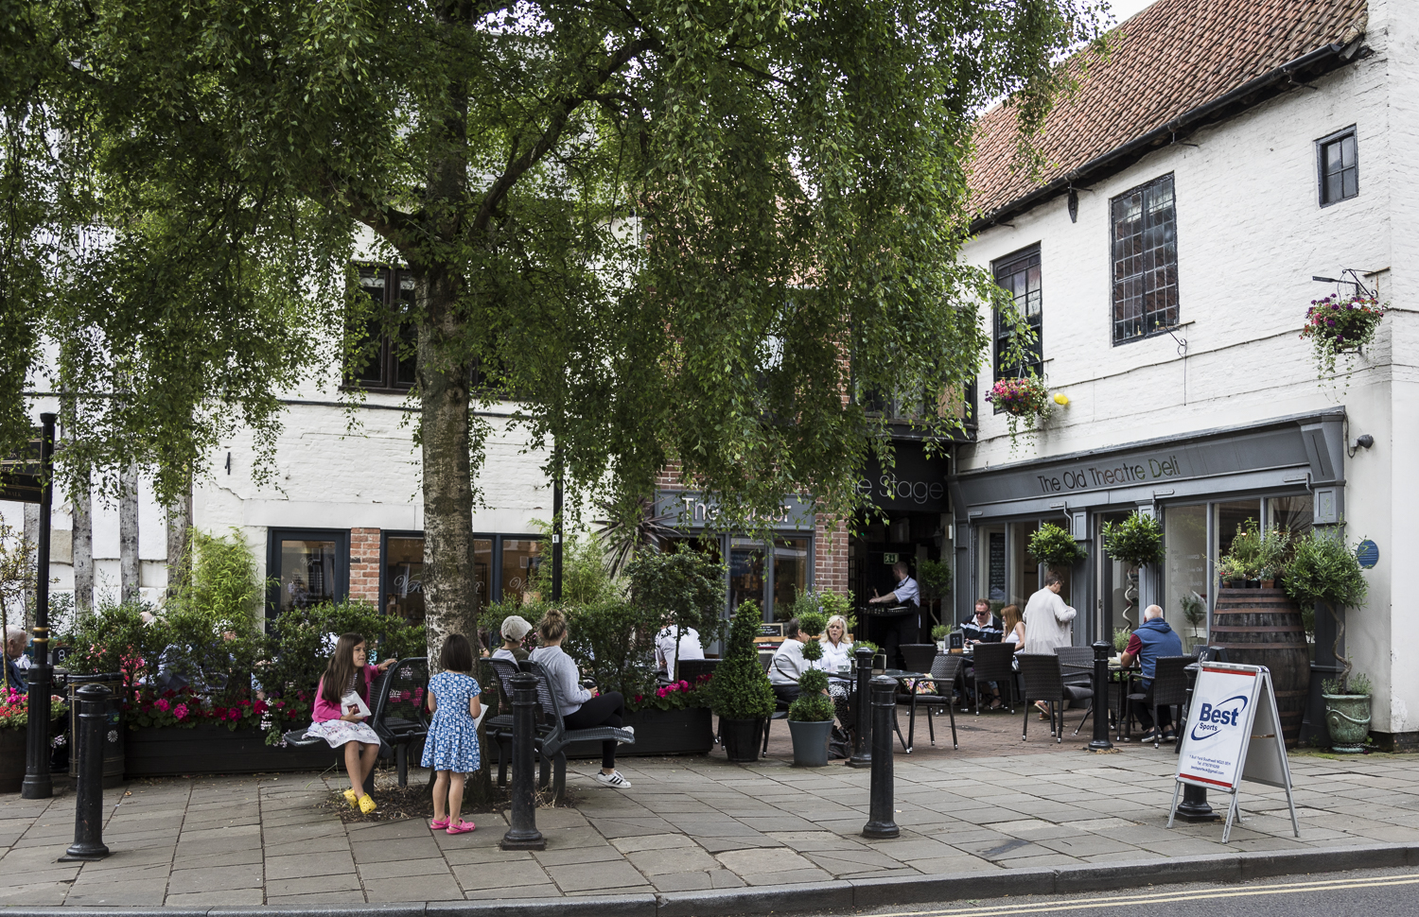
There are outstanding local Primary and Secondary schools with the Minster School being just down the road from the church. There is also good preschool provision in the town. The Brackenhurst Campus of Nottingham Trent University is one mile from the church. The Leisure Centre is just a two-minute walk away providing various Sports Clubs. Southwell hosts a number of cultural events throughout the year and there are many special interest clubs.
There are good transport links to the surrounding area. Nottingham is 16 miles away, Lincoln 26 miles and Newark 8 miles. From Newark there is easy access to the A1 and a fast train service to London and Edinburgh.

Church History
The origins of Southwell Baptist Church can be traced back to the early 1800s when itinerant preachers began to preach in the open air. The first official church started in 1811 with the help of Friar Lane Baptist church in Nottingham. Services were held in a converted barn and the local stream was damned up when Baptism services were held. This makes us the second oldest congregation in town.
In 1839 the church purchased the local workhouse and turned it into a church and a manse. This is the building which we have today, with the deeds held in trust by the Baptist Union.
It has seen many alterations and improvements to ensure that it meets the current needs of its members.

Practical Matters
We intend making this appointment in line with BU Recommended Terms of Appointment. As our manse needs extensive renovation we intend to discuss a range of alternatives for accommodation appropriate to the applicant.
We will enable and encourage our minister to participate in the Baptist Union’s CMD programme.

